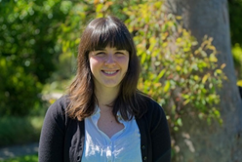
Researcher Profile: Caitlin Adams

Fast Facts

Name
Caitlin Adams

Job title
PhD Student, Swinburne University of Technology

Where did you go to primary school and secondary school?
Mount Tamborine, in the Gold Coast hinterland.

When you were a child, what did you want to be when you grew up?
I initially wanted to be an artist, but in high school I started to be more interested in science as a career and art as a hobby.

Where have you studied since finishing school?
I did my degree at the University of Queensland in Brisbane for four years, and now I’m undertaking my PhD at Swinburne University of Technology in Melbourne.

Where have you worked?
I’ve predominantly worked as a tutor at the University of Queensland, but have also done summer research projects there and at the Australian National University in Canberra.

Describe your research in 150 characters or less.
We don’t know why the universe is expanding at an accelerating rate - but I’d love to find out!

What is the best part of your job?
There are many great things about doing a PhD, but one of the things I most enjoy is that I get to learn new things all the time - from new discoveries in other fields to new methods for problem solving.

Name one impressive instrument that you’ve used for your research.
I have used the National Computational Infrastructure, one of the most powerful supercomputers in Australia, to run simulations on how matter is distributed in the universe.

What skills are essential to your job?
I frequently rely on my skills in computer programming and mathematics, as well as being able to communicate well with other researchers, but I’m always improving and adding to those skills while I work.

What advice would you give a school student who wants to become a scientist?
Go for it! It is unlike any other career path: you’ll be challenged, meet people from all over the world, and help contribute knowledge to something you think is worthwhile!

What are some futuristic applications that might come from your research?
If we could understand what is causing galaxies to move away from each other at an ever faster rate, perhaps we could make use of it for space travel. But I think some of the beauty of this research is that the possibilities are largely unknown and unimaginable!

What do you do for fun in your spare time?
I really enjoy drawing and reading, and I’ve started taking courses online to expand my knowledge: right now, I’m learning Japanese!

Research in detail

Cosmology is the study of the Universe as a whole: how it began, what it contains, and how it grows — it’s this last question I’m most interested in. In the late 90s, two teams of scientists discovered that the Universe is expanding at an accelerating rate — galaxies are being flung apart faster and faster as the space between them grows. Until this point, we had thought that the expansion would slow down, as galaxies moved closer together due to gravitational attraction, but our measurements tell us that’s not the case. So what’s pushing all of these galaxies apart?

The short answer is: we don’t know! Many researchers are pursuing this question in earnest, and there are many different approaches. In my PhD, I am looking at how the distribution of galaxies can help us answer this question. I take different theories of what might be causing the expansion (such as extra energy in space, or gravity deviating from Einstein’s theory of general relativity) and look at the predictions they make about the distribution of galaxies. I can also perform deeper tests by using information about how those galaxies are moving relative to each other, which gives a fuller picture of how our universe is influencing these galaxies. My goal is to combine all of this information in a unique way to test our understanding of the expansion of the Universe.

The work I do relies on large surveys of the Universe, which collect the positions and velocities of hundreds of thousands of galaxies. This is the data that I want to compare wih theoretical models. I then use mathematics and statistics to come up with approaches that test the predictions of compelling theories against what we measure, and write computer programs to do these tests. Lots of my most recent work has been building these tests and trying them out on computer-generated data, to see if my approach is working the way I expect. So far so good, and I hope to apply these methods to real data very soon!

Images
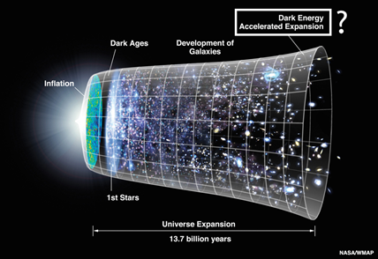

Time Line of the Universe
Image credit: NASA/WMAP Science Team [Public domain], via Wikimedia Commons
https://commons.wikimedia.org/wiki/File%3ACMB_Timeline75.jpg
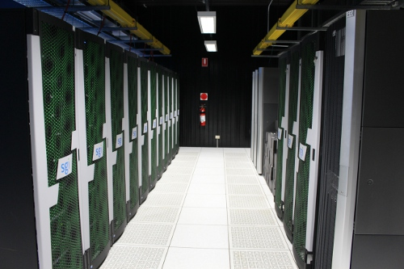

Swinburne University of Technology Supercomputer. Image credit: Caitlin Adams
“Much of the work I do is too complicated to run on my personal computer, so I send tasks to Swinburne’s supercomputer, Green II (http://supercomputing.swin.edu.au/about-green-ii/). Supercomputers are a collection of processors (the part of a computer that runs programs and performs calculations) that are able to share information quickly, allowing them to tackle larger problems than a single processor in a personal computer. Green-II’s processors are housed in the cases displayed here.”

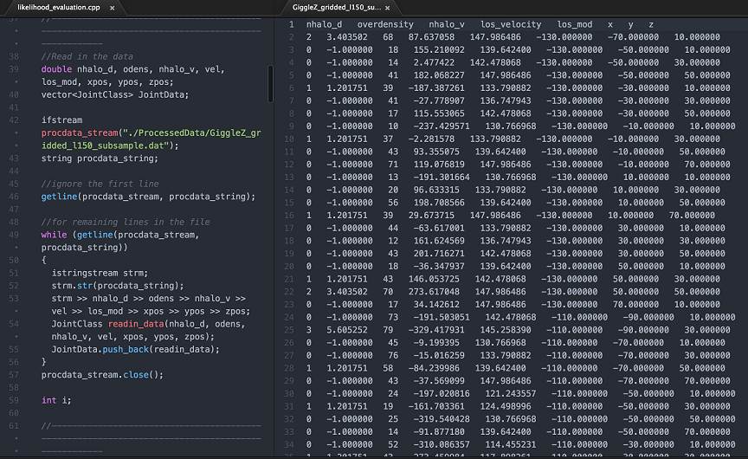Screen shot of computer programming code and astronomical data. Image credit: Caitlin Adams
“The code in the left panel is used to read in simulation data, which is displayed in the right panel. These data describe galaxy positions and velocities at different points in space, and in my research I’m using close to 1000 of these simulated galaxies. The galaxies I’m using come from the Gigaparsec WiggleZ simulations.”

