Researcher Profile: Professor Tamara Davis
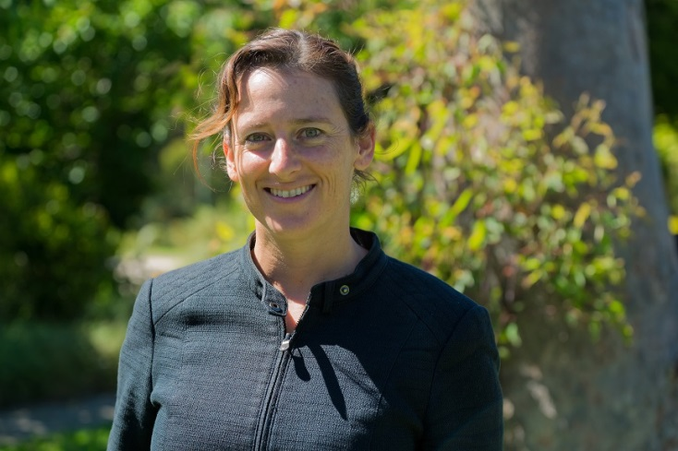

Fast Facts

Name
Tamara Davis

Job title
Professor in the School of Mathematics and Physics at the University of Queensland

Where did you go to primary school and secondary school?
St Catherine’s School, Sydney

When you were a child, what did you want to be when you grew up?
An astronaut, an architect, or a bricklayer (I liked LEGO).

Where have you studied since finishing school?
University of New South Wales (UNSW), where I did a combined Science/Arts degree, in physics and philosophy. I also did my PhD at UNSW, in astrophysics. I also did three of my undergrad semesters at the University of British Columbia in Vancouver, Canada.

Where have you worked?
My first postdoctoral fellowship was at the Australian National University, but I was also working for Lawrence Berkeley National Laboratory in San Francisco, USA. Then I went on to a research fellowship at University of Copenhagen, before my final research fellowship at the University of Queensland in Brisbane became a permanent job.

Describe your research in 150 characters or less.
I use huge natural experiments, such as exploding stars and the universe expanding, to learn about fundamental physics. In particular I search for the elusive “dark energy” that’s accelerating the universe.

What is the best part of your job?
Working with amazing, inspired people, all around the world, on topics we're passionate about. Figuring out how the world works. And seeing the "ah ha" moments in other people's eyes when you help them figure it out too.

Name one impressive instrument that you’ve used for your research.
The Very Large Telescope (VLT) in Chile. Watching the massive lasers they shoot at the sky to bounce off the atmosphere to help adapt the shape of the mirror to get rid of the distortion due to the atmosphere, is one of the most impressive things I've seen.

What skills are essential to your job?
Strong computing skills are essential, and good mathematical skills. But most important is persistent fascination, the desire to discover, and the ability to identify interesting questions.

What advice would you give a school student who wants to become a scientist?
Do it! It is the best job in the world. You get to make your own hours, and go to work each day to try to figure out the problem that you think is most interesting. And you get to travel around the world to work with fantastic people, with top technology, on questions no human has ever figured out before. Awesome!

What are some futuristic applications that might come from your research?
I'm hoping we discover a way to make a new type of clean energy, or propulsion systems (hover boards?!). But at the very least we'll come up with cool spin-offs like superb cameras, new medical imaging techniques.... and who knows!

What do you do for fun in your spare time?
I play lots of sport. Ultimate Frisbee and rock climbing are my latest ones. I'm a tiny bit competitive, so try to do as well as I can in no matter what it is I try.

Media
“Unique, but not exceptional”, Physics World, August 2015
https://smp.uq.edu.au/people/TamaraDavis/papers/PWAug15reviews-davis.pdf

Videos
- Brain Box interview - astrophysicist Professor Tamara Davis, Australian Academy of Science, 2015 https://youtu.be/axkTQwYt6io
- Perspectives from dark space: Tamara Davis at TEDxNoosa 2014 https://youtu.be/klULtUE6lrk
- ONExDARKMATTER: Tamara Davis at TEDxBrisbane, 2013 https://youtu.be/zJCa0_2Kess
- Dr. Tamara Davis, 2009 L'ORÉAL For Women in Science Fellow, 2011 https://youtu.be/g1Q7ilaUoiQ

Twitter handle
@tamarastro

Personal website
https://smp.uq.edu.au/people/TamaraDavis/

Research in detail
I am a cosmologist, and spend most of my time trying to figure out why the expansion of the universe is accelerating – in other words, I am searching for dark energy. One of the projects I work on is the Australian Dark Energy Survey (OzDES). OzDES is a 5-year survey using 100 nights on the Anglo-Australian telescope to collect data on galaxies that are being monitored by the international Dark Energy Survey. Amongst the many varied aims of this survey is to discover about 2,500 type Ia supernovae. A supernova is very bright astronomical object resulting from a catastrophic event at the end of the life of a star. The original Nobel-prize winning discovery of dark energy was made using measurements from just 52 supernovae. With a couple of thousand supernovae we can make the best-ever measurement of the expansion of the universe.

I also do research on Active Galactic Nuclei (AGN) to ‘weigh’ supermassive black holes. AGN emit a lot of electromagnetic radiation and they are fuelled by supermassive black holes consuming gas at the centres of galaxies. While the gas is falling into the black hole, it gets extremely hot and shines brightly, ionising a bubble around it and illuminating the clouds of dust and gas on the outskirts. The brightness varies as clumps of matter fall in. We're watching the brightness vary using images from the Blanco telescope in Chile and then detecting the "reflection" of that light from the surrounding clouds using spectra from the Anglo-Australian Telescope. By measuring the time delay between the two we can "weigh" the black hole, because more massive black holes make hotter gas, which ionises a bigger bubble, so the light has to travel for longer before being reflected from the emission line clouds.

Dark Energy Survey homepage: https://www.darkenergysurvey.org/
OzDES homepage: http://www.mso.anu.edu.au/ozdes/

Images
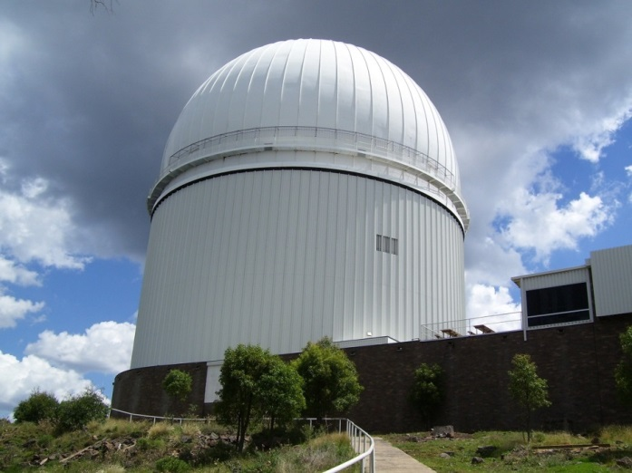
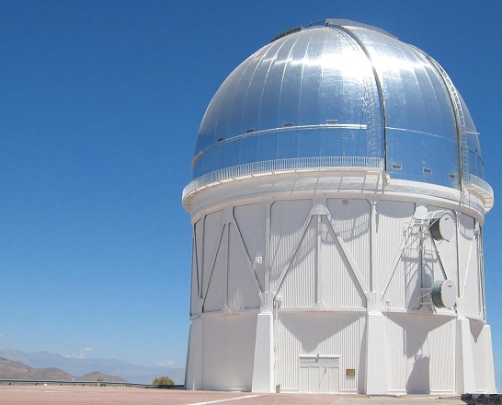

LEFT: Blanco telescope in Chile
By User:Denys (Pris par Denys (fr)) [GFDL (http://www.gnu.org/copyleft/fdl.html) or CC BY 3.0 (http://creativecommons.org/licenses/by/3.0)], via Wikimedia Commons

RIGHT: Anglo-Australian Telescope, Coonabarabran, New South Wales
By Diceman Stephen West (Own work) [CC BY-SA 3.0 (http://creativecommons.org/licenses/by-sa/3.0) or GFDL (http://www.gnu.org/copyleft/fdl.html)], via Wikimedia Commons

