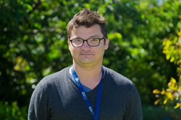
Researcher Profile: Alex Codoreanu

Fast Facts

Name
Alex Codoreanu

Job title
PhD Student, Swinburne University of Technology

Where did you go to primary school and secondary school?
I attended primary school in Bucharest, Romania and then attended several different high schools in the United States.

When you were a child, what did you want to be when you grew up?
As a child, I really loved reading and finding things out and I wanted to keep doing that but I had no clear idea what that meant. I always dreamed of adventure so in the back of my mind I always wanted to be an explorer, so astronaut was at the top of that list!

Where have you studied since finishing school?
I took a fairly long break between high school and university and during that time the one thing that I enjoyed studying on my own is audio production. I'm glad to have been involved in the creative process with different musicians, helping their visions evolve to a finished product.

Where have you worked?
Before starting in my university career I worked as a live sound engineer and event programmer for a few music venues. As I progressed through the first years of coursework at university, I began working as a research assistant at the University of Minnesota. As such, I worked on direct dark matter detection with the Super Cryogenic Dark Matter Search program. I also worked on simulating ‘grism’ observations for the Euclid Space Telescope, which is due to be launched in December 2020. A ‘grism’ is sometimes called a grating prism and it is used to break light into different colours (wavelengths). I've also worked as a personal tutor and lab coordinator.

Describe your research in 150 characters or less.
We are made of star stuff! My research looks at metals from when the universe was just 1 billion years old through to today, to try to understand how the universe evolved.

What is the best part of your job?
The best part is that there is no one part that is best. My job is to be able to do many jobs and handling all of these different parts in a successful manner is incredibly rewarding.

Name one impressive instrument that you’ve used for your research.
I use the aptly named Very Large Telescope in Chile to do my science.

What skills are essential to your job?
The wonderful thing about Astrophysics is that it is a new scientific field which incorporates a lot of recent physical concepts with even newer technology. We must be skilled in all aspects of Physics such as Quantum/Newtonian/Statistical Mechanics, Thermodynamics and Nuclear Physics. All of that is based on a very friendly relationship with Mathematics. We must also be skilled programmers, both in high and low level languages depending on the applications.

Astrophysics is also an incredibly transparent and collaborative community. I have to be very comfortable with presenting my work, in writing and in oral presentations. Because of the small size of the community, collaborative skills are also a must!

What advice would you give a school student who wants to become a scientist?
I would advise anyone that wants to pursue science to have the confidence in choosing a field that makes them curious. It is a long road to understanding a field of science well enough start having new ideas to push the limits of what we know. Without that natural curiosity, that long road can be very difficult. The good news is that with natural curiosity, the same road can be a very exciting journey.

What are some futuristic applications that might come from your research?
A future application of my work is the ability to make 3D maps of the gas distribution of the local universe!

What do you do for fun in your spare time?
I really enjoy cooking during my spare time and make a lot of things from scratch. I still play and record some music at times. If I have more than a weekend or so, I enjoy traveling and hiking or swimming. Australia is pretty good for those kinds of city escapes!

Media/videos
http://www.labnews.co.uk/features/responsibility-reach-11-08-2015/

Twitter handle
@cosmos_cola

Personal website
http://astronomy.swin.edu.au/staff/acordoreanu.html

Research in detail

My research looks at the light and other electromagnetic radiation that comes from quasars. Quasars are very bright objects, so we can observe them using telescopes even if they are a very long way away. In astrophysics, we often talk about distances in terms of ‘light years’, because one light year is the distance that light can travel through space in one year (300,000 kilometres). We can observe quasars that are more than 13 billion light years away. The Universe began with the Big Bang 13.8 billion years ago, and by looking at quasars, I can try to discover more about how the Universe has evolved since the Big Bang.

As light from a distant quasar travels through the Universe, some of the light is absorbed by matter in the Inter Galactic Medium (IGM). This matter is a very diffuse, very hot gas, and some of the material in the IGM has come from stars. By measuring how much light is absorbed, and which colours are absorbed more than others, we create absorption profiles. Absorptions profiles then tell us which elements are in the IGM. I look at the amount of Carbon, Oxygen, Silicon and other metals, in their different ionisations states and try to work out what types of stars produced the material in the IGM.

As the Universe evolved after the Big Bang, more and more stars formed. The stars were fuelled by hydrogen and nuclear fusion of hydrogen inside the stars created heavier and heavier elements. By discovering which elements were present in the IGM in the first billion years after the Big Bang, I can collect information about the types of stars that existed at that time and how many of each type existed. These are known as ‘stellar population models’ and ‘number density’ and they could lead to a better understanding of the processes in the evolution of the Universe.

Images

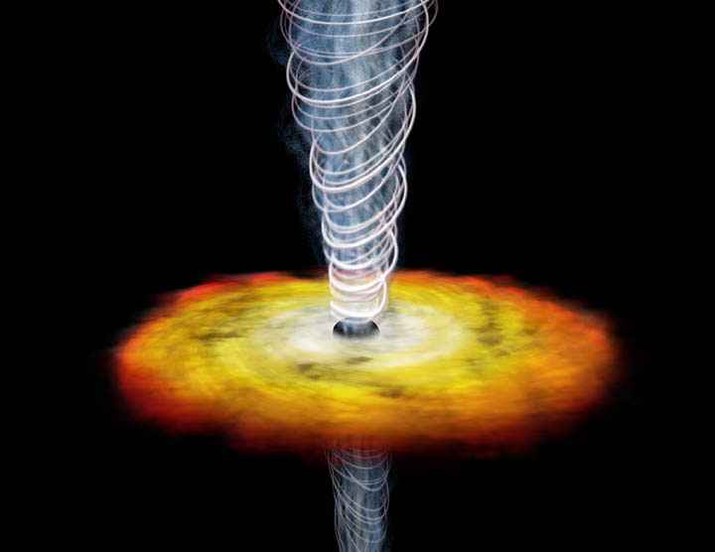
An artist's impression of a quasar galaxy.
Image credit: "Gb1508 illustration" by NASA - Licensed under Public Domain via Wikimedia Commons - https://commons.wikimedia.org/wiki/File:Gb1508_illustration.jpg#/media/File:Gb1508_illustration.jpg
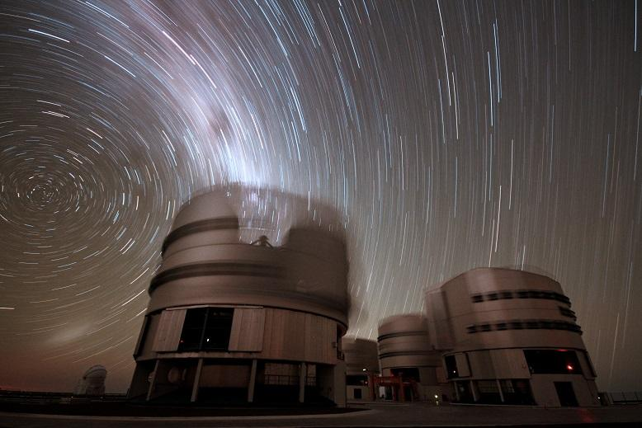
A view of Paranal from May 1987, an observatory in Chile and the home of the Very Large Telescope
Image credit: ESO - http://www.eso.org/public/images/paranal/. Licensed under CC BY 4.0 via Wikimedia Commons - https://commons.wikimedia.org/wiki/File:A_view_of_Paranal_from_May_1987.jpg#/media/File:A_view_of_Paranal_from_May_1987.jpg

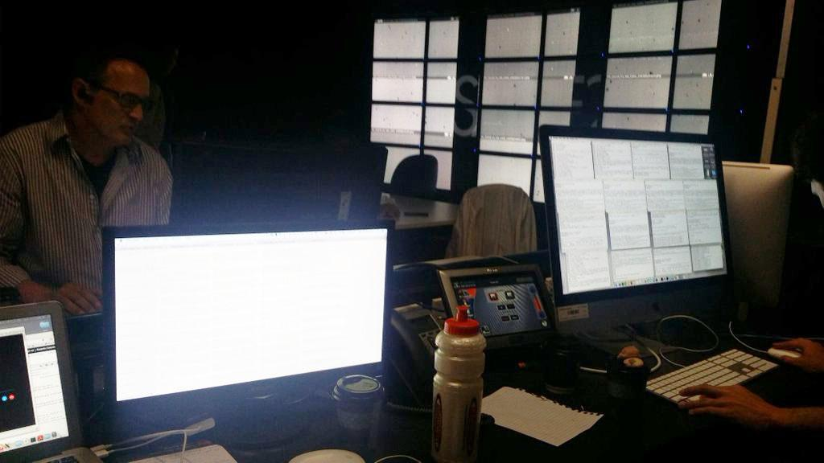

Control centre at the University of Melbourne showing workstations and a tiled wall display of astronomical images. The researchers use the images to confirm visually any interesting changes detected in data. Image credit: Alex Codoreanu

