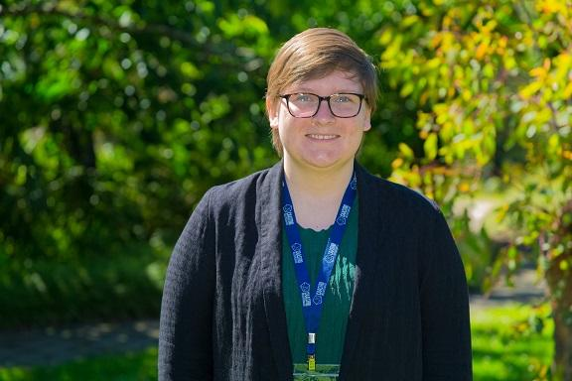
Researcher Profile: Dr Christene Lynch

Fast Facts
Name
Dr Christene Lynch

Job title
Postdoctoral Research Associate

Where did you go to primary school and secondary school?
I attended primary and secondary school near Baltimore Maryland, in the United States.

When you were a child, what did you want to be when you grew up?
I have always wanted to be a scientist. I have an uncle and aunt who are biologists and study endangered species of animals. Their job takes them all over the world to study the habitats and behaviour of the most rare animals on the Earth. So originally I wanted to be a biologist like them. However as I progressed through school, I found that in addition to science, I really love mathematics (especially algebra!). Once I took physics in secondary school and realised that physics allows me to understand the natural world using mathematics, I knew I wanted to be a physicist.

Where have you studied since finishing school?
I earned both my degrees in the United States. I did my undergraduate degree (Bachelor of Science) in physics and mathematics at Gettysburg College, which is located in central Pennsylvania. I then moved to Iowa City and earned a PhD in physics at the University of Iowa.

Where have you worked?
During my undergraduate career I did summer internships at the Stanford Linear Accelerator Centre (SLAC) and the Harvard-Smithsonian Centre for Astrophysics (CFA). Both internships involved studying extreme stellar systems. At SLAC I worked on a computer model of the first star in the universe forming; this star was hundreds of times more massive than our Sun and most likely ended up as a black hole. At the CFA I analysed optical observations of a binary system that goes through a small explosion every 20 years. As a graduate student I worked as a teaching assistant for introductory Physics and Astronomy laboratory classes.

Describe your research in 150 characters or less.
The smallest stars in our galaxy host some of the brightest stellar flares. I carry out large observing programs to search for these flares.

What is the best part of your job?
I love working with observations and data, so I always find starting the analysis of a new set of data very exciting. Since my research involves looking for the rare stellar flare, there is a sense of mystery when you start your analysis. You aren’t always sure if this dataset will lead to a detection and big discovery or just more questions that need to be answered.

Name one impressive instrument that you’ve used for your research.
I use the Murchison Widefield Array, a radio telescope located in Western Australia.

What skills are essential to your job?
Communication is probably the most important skill to a scientist. No one will know about or understand any of your discoveries if you can’t communicate what you did and why it’s important. This involves both written and oral communication. As a scientist you have to write about your discoveries in science journals as well as present these discoveries to other scientists around the world. So being able to write and talk about your science is very important.

I also use mathematics and computer programming everyday. I write computer programs that carry out the analysis of my observations and then use mathematical models to explain the results of this analysis.

What advice would you give a school student who wants to become a scientist?
I would suggest that they study all types of science. If I had stuck with biology in secondary school, then I would never have known how much I like physics. So keeping an open mind and trying everything allows you to find what you are most passionate about. That passion is important when studying to become a scientist. There can be set-backs or stress when trying to become a scientist but if you are passionate about what you do then you will have more motivation to keep going.

I would also suggest that taking computer programming classes. All scientists need to be able to use computers to do their work and a lot of that work involves writing code or software that does your analysis or modelling. Lastly, students should keep in mind that writing is a big part of being a scientist, so continuing to focus on writing skills is important.

What are some futuristic applications that might come from your research?
Currently we don't understand how stars produce energetic flares or how often stars go through flare events, including flare events occurring on our own Sun. This is a problem since the flares that come from our Sun can damage the satellites we use for communication. Being able to predict when these flares are going to occur on the Sun would help us to better protect our satellites. My research will hopefully lead to a better understanding of how often the Sun and other stars produce these flares and allow us to be able to one day predict when these flare events are going to occur.

What do you do for fun in your spare time?
I am an avid reader as well as a distance runner. Currently I am getting marathon ready for the Sydney 2016 race! When not reading or running, I also enjoy going to concerts and playing Dungeons and Dragons with a group of friends.

Media/videos
CAASTRO Media Release, February 2016: ‘Radio-loud ultracool dwarfs allow analysis of magnetic fields’ http://www.caastro.org/news/2016-ucd

Research in detail
A number of the smallest stars in our galaxy are sources of bright radio pulsess. These radio pulses are sometimes found to occur periodically and last only a few minutes. The radio pulses are thought to be the result of magnetic processes occurring on the star. As electrons are accelerated toward the atmosphere of the star, they spiral around the star’s magnetic field and produce radio frequency radiation. When they eventually hit the atmosphere, they excite the atoms in the atmosphere and produce auroral emission similar to those seen here on Earth.
The presence of magnetic fields in dwarf stars is unexpected. From studying the Sun’s magnetic field, astronomers discovered its presence depends greatly on the Sun’s interior structure. The interior of dwarf stars is very different from that of our own Sun and it is not clear how these stars are able to generate their magnetic field. Additionally, astronomers are not sure why some dwarf stars are observed to have these radio pulses while other dwarf stars do not. My research addresses this last point. By having a large number of sources, which are observed to produce these radio pulses, we can determine if things such as the rotation of the star or the star’s temperature have a role in whether these objects produce radio emission.
My research involves observing large areas of the sky to look for radio pulses from dwarf stars. Telescopes, like the Murchison Widefield Array, can observe the full Southern sky in a short period of time because they can look at large portions of the sky simultaneously. The Murchison Widefield Array has a view with a width of 30 degrees. This is the same size as 60 of our Moons lined up across the sky. This wide view is important for my work because it allows me to observe many hundreds of stars simultaneously. Since these radio pulses are relatively rare, being able to observe large numbers of stars is essential to my research.

Images
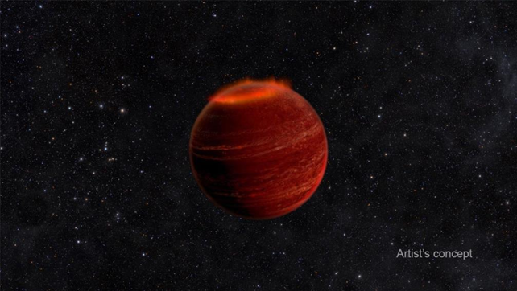

An artist's conception of auroral emission on a brown dwarf. These aurora are thought to be a
million times brighter than an aurora on Earth. Image credit: Chuck Carter and Gregg Hallinan/caltech http://www.jpl.nasa.gov/news/news.php?feature=4676

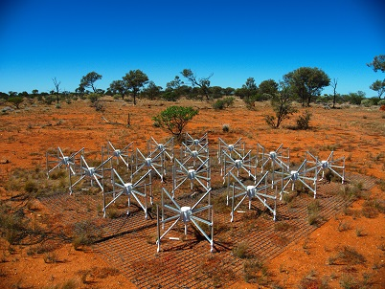

Murchison Widefield Array, radio telescope located in Western Australia
Image credit: By Natasha Hurley-Walker (Own work) [CC BY-SA 3.0 (http://creativecommons.org/licenses/by-sa/3.0)], via Wikimedia Commons

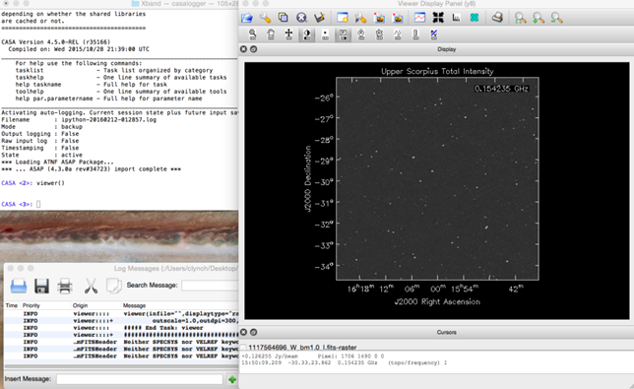

Screen shot of astronomical image analysis tool: I use several different tools to analysis my astronomical images. Here the right panel is a radio image of the Upper Scorpius star forming region and then on the left hand side is a terminal where I type in commands to analyse the image. I do things like measure the brightness of a point or determine the angular size of an object in the image.

