Spectroscopy

These worksheets are designed to be read by students before viewing a CAASTRO in the Classroom video conferencing or streaming session. The ‘Pre-visit activities’ can be completed prior to the session and the ‘Post activities’ are provided as suggestions for follow-up activities.

Table of contents
Click on the links below to jump to the relevant section.

Table of contents
Pre-visit Activities
Glossary
Revision Videos
Post-visit Activities
Practice Questions
Question 1 – Light and colour
Question 2 – Types of spectra
Question 3 – Astronomical spectra
Online Interactives
Interactive 1 – Emission spectra of elements
Interactive 2 – Blackbody spectrum
Interactive 3 – Decoding cosmic spectra

Pre-visit Activities

Glossary
The following terms may be cited during the session. If students need assistance, refer them to the ‘Revision Videos’ section or any Physics textbook.

Terms | Definition
Absorption spectrum
Atmosphere
Black body
Black hole
Continuum spectrum
Emission line
Emission spectrum
Flux
Galaxy
Nebula
Orbital
Photon
Planetary nebula
Prism
Refraction
Spectrograph
Spectroscopy
Spectrum
(plural = spectra)
Star
Supermassive black hole
Terrestrial
Wavelength
White dwarf
Revision Videos
The following is a list of useful revision videos. Students can:
- Take notes on the videos for themselves; OR
- Review one or more of the videos for their classmates as a homework exercise, giving each video a rating and commenting on how well the video communicated the science content.

- This Crash course astronomy video will explain how light is used to study the universe.
https://www.youtube.com/watch?v=jjy-eqWM38g
Crash Course: Light

- Brian Cox explains the importance of light to understanding the universe.
https://www.youtube.com/watch?v=n_KyYFYNvpI
BBC Two: Wonders of the Universe

- How do we know what stars are made of?
https://www.youtube.com/watch?v=h2kzT6CEhVs
Max Planck Society: Spectroscopy – splitting the starlight

- Spectroscopy explained by NASA
https://www.youtube.com/watch?v=SPgYrsONgwU
NASAeClips: Neon lights – spectroscopy in action

- Emission and absorption spectra explained.
https://www.youtube.com/watch?v=1uPyq63aRvg
Bozeman Science: Emission and absorption spectra

- How astronomers use light.
https://www.youtube.com/watch?v=5GIvktBSxvw
Institute of Physics: The electromagnetic spectrum

- Using light to see what is in the atmosphere of other planets.
https://www.youtube.com/watch?v=UfJ-i4Y6DGU
Minute Physics: How do we know what air is like on other planets?

- Electron movement produces spectral lines.
https://www.youtube.com/watch?v=JlwMYcF1NLg
David Butler: Classroom Aid - Spectroscopy

- What exactly is blackbody radiation?
https://www.youtube.com/watch?v=NqUPEnbrz44
P.E. Robinson: Introductory astronomy – Blackbody spectra

- All about the solar spectrum (high level).
https://www.youtube.com/watch?v=l_MHRuBJE6Q
Sky Scholar: The solar spectrum in the standard solar model

Post-visit Activities

Practice Questions

Question 1 – Light and colour

- On the prism below, show a beam of white light coming in and being split up into its component colours.

b) (i) What is the correct term for the bending of light?
(ii) How many nanometres in a metre?
(iii) List the colours that make up white light.

(iv) On the spectrum below, note the wavelengths of the different colours of light.

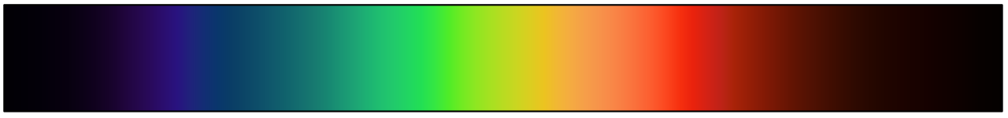

c) On the same axes, sketch the spectra of a red object and a blue object. Note that flux is used for astronomical objects to measure brightness at particular wavelengths. It depends on the luminosity of the object (L) and the distance from Earth (r).
$$Flux= \frac{L}{4πr^{2}}$$

Flux

Wavelength (nm)

Question 2 – Types of spectra

- Identify the types of spectra shown here.

__________________________spectrum

__________________________spectrum

__________________________spectrum

- Explain how the different types of spectra shown on the previous page are produced.

- A spectrograph uses a diffraction grating rather than a prism. Conduct research to find out how a diffraction grating works. Include a diagram with your answer.

- The spectrum of each element is like a fingerprint—no two elements have the same spectrum. Use atomic structure to explain why this is and explain whether or not the atomic models below are sufficient to explain the appearance of the corresponding spectra.

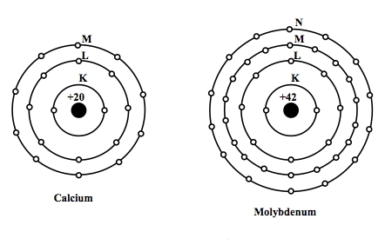
Calcium
Molybdenum

Question 3 – Astronomical spectra

- (i) This image shows the spectrum of the Sun set against that of a black body source. Explain what a black body is and why the Sun’s spectrum differs from that of a black body.

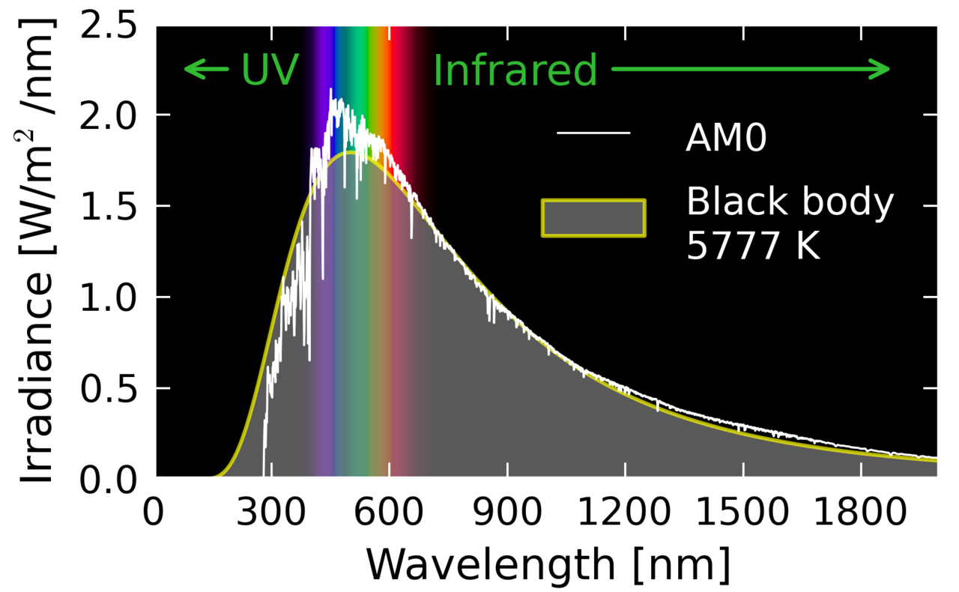

a) (ii) How would the Sun’s spectrum change if viewed through the Earth’s atmosphere?

b) This spectrum from NASA’s Spitzer Space Telescope shows that white dwarfs are surrounded by a cloud of dust. The wavelengths shown are in microns (micrometres, 1µm = 1000nm)

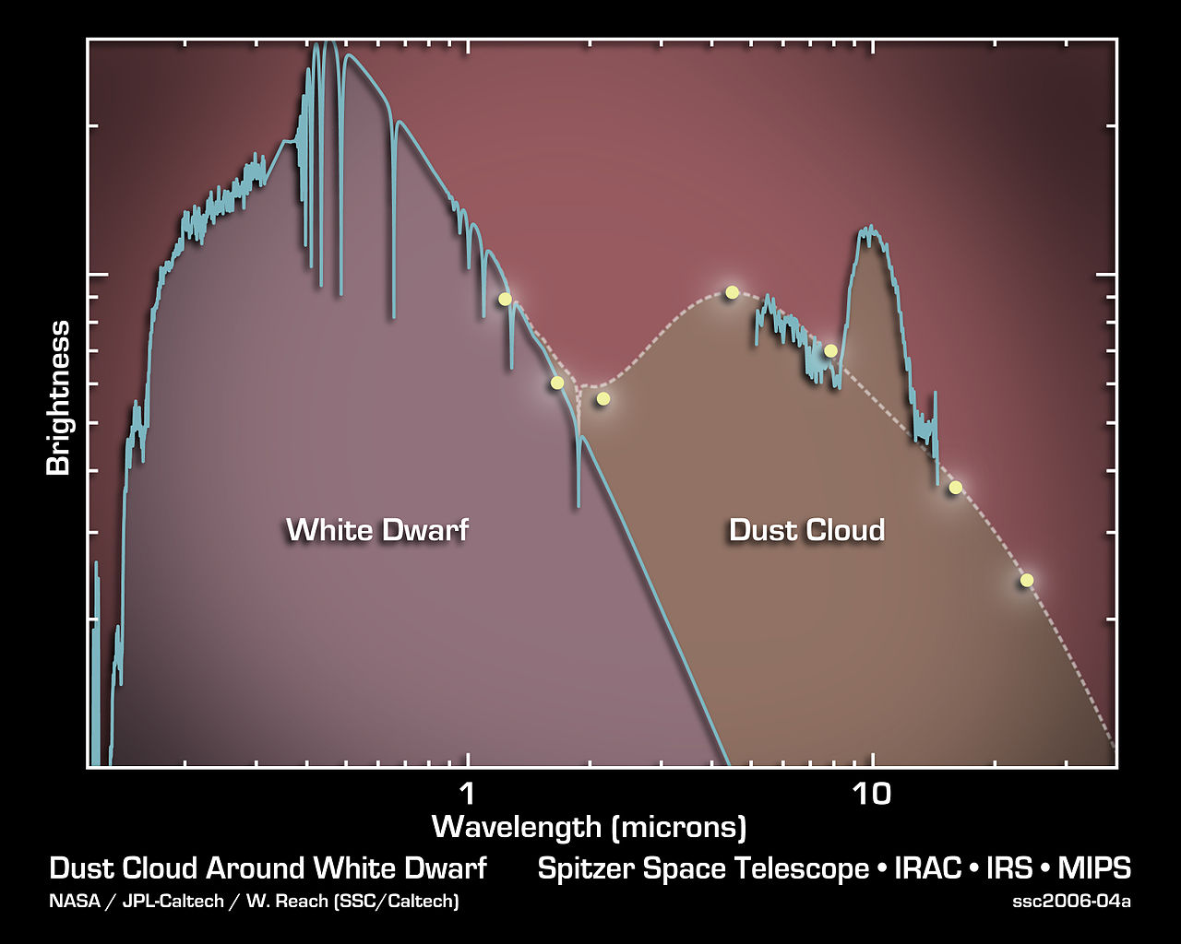

- On the spectrum above, indicate where the visible region is.
- What are two pieces of information about the white dwarf that could be deduced from this spectrum?

c) This spectrum from NASA’s Spitzer Space Telescope shows substances present in galaxy IRAS F00183-7111. The light from this galaxy took 3 billion years to reach Earth.

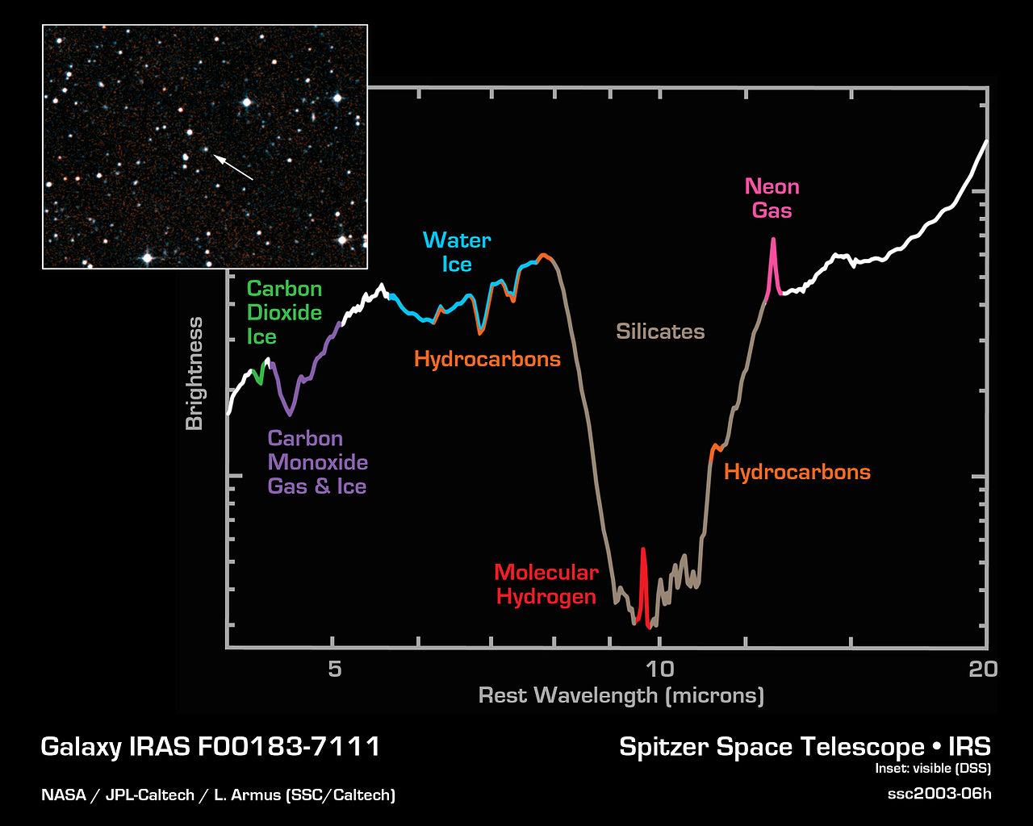

What is the significance of the compounds and elements found in galaxy IRAS F00183-7111 compared to our own solar system?

Online Interactives

Interactive 1 – Emission spectra of elements
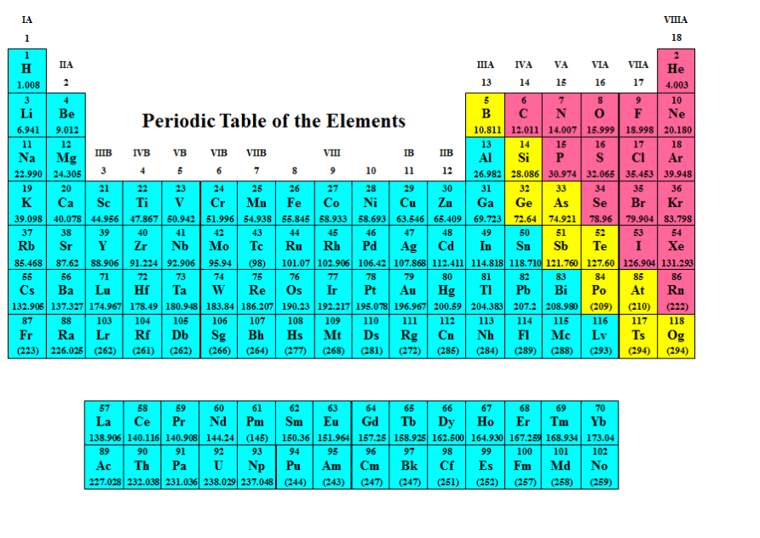 | Dr Alan J. Jircitano, Penn State University  http://chemistry.bd.psu.edu/jircitano/periodic4.html  This interactive shows the emission spectra of known elements.

Instructions:
- Click on an element to view its emission spectrum.
- Note the similarities and differences between the spectra for smaller and larger atoms.
- Which elements have no known spectrum? Why do you think these elements don’t have identified spectra?

Interactive 2 – Blackbody spectrum
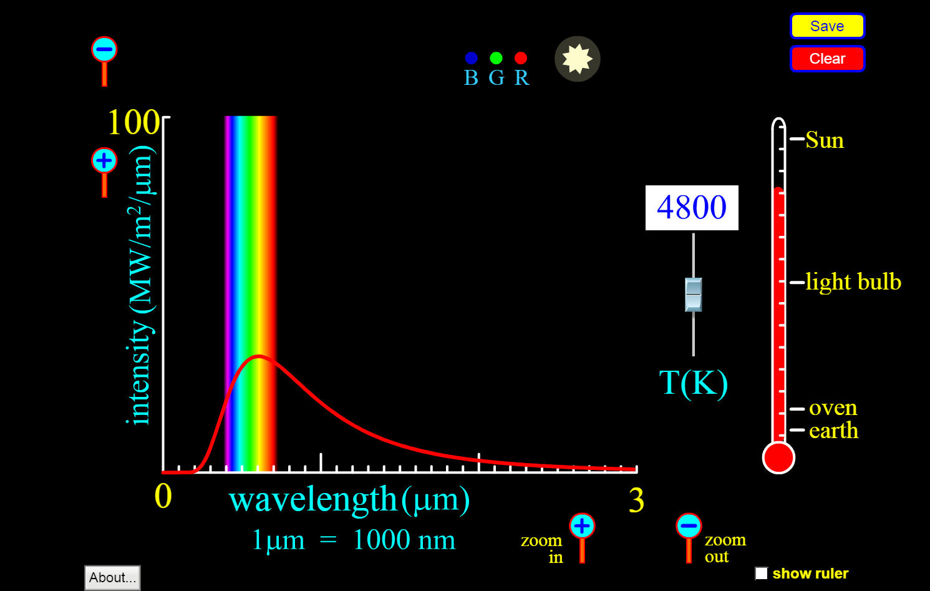 | PhET interactive simulations, University of Colorado, Boulder  https://phet.colorado.edu/sims/blackbody-spectrum/blackbody-spectrum_en.html  This interactive allows students to explore the black body spectra for objects at different temperatures.

Instructions:
- Use the temperature control to adjust the temperature of the blackbody radiation source.
- Note what happens to the position of the peak as the temperature increases.
- Note what happens to the star colour as the temperature increases.
- Set the temperature to 5800K, which is approximately the surface temperature of the Sun. Where is the peak at this temperature, and what colour would this correspond to?

Interactive 3 – Decoding cosmic spectra
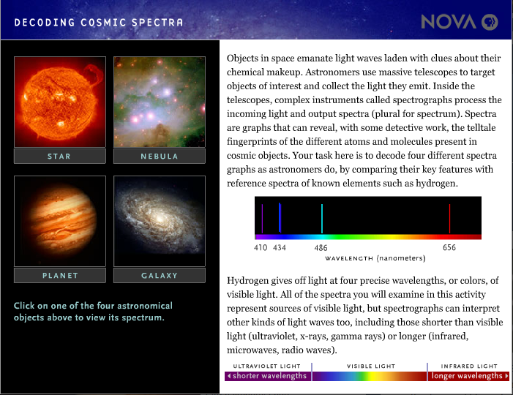 | Lexi Krock, NOVA  http://www.pbs.org/wgbh/nova/space/decoding-cosmic-spectra.html  This interactive allows students to explore four different types of astronomical objects and match the substances in them to the spectra.

Instructions:
- Click on the first object, Star.
- Determine the wavelength that the blue question mark corresponds to.
- Scroll through the spectra until you find the element or compound that matches the wavelength in question. Click “Match”.
- Repeat this process for the other question mark positions.
- Repeat entire process for Nebula, Planet and Galaxy.

