Big Bang

These worksheets are designed to be read by students before viewing a CAASTRO in the Classroom video conferencing session or a recording of a past video conference. The ‘Pre-visit activities’ can be completed prior to the video conference session and the ‘Post activities’ are provided as suggestions for follow-up activities.

Table of contents

Table of contents
Pre-visit Activities
Glossary
Glossary with answers
Revision Videos
Post-visit Activities
Online Interactives
Interactive 1 - Sizing up the universe
Interactive 2 - The Scale of the universe
Interactive 3 - Stellarium
Interactive 4 - Galaxy Zoo
Practical Activities
Activity 1 - Big Bang Timeline
Activity 2 - Expansion of the Universe
Activity 3 - Extremely simple redshift modelling
Activity 4 - Homemade spectroscope
Useful Links

Pre-visit Activities

Glossary
The following terms may be used during the video conferencing session. If students need assistance, refer them to the ‘Revision Videos’ section, an online dictionary or reference book.

Terms | Definition
Star
Gravity
Galaxy
Black hole
Universe
Light year
Supernova
Red shift
Fusion
Nebula
Red giant
White dwarf
Neutron star
Super giant

Glossary with answers

Terms | Definition
Star | A huge ball of hot gas that produces its own energy (as light) via nuclear fusion.
Gravity | The force of attraction between two objects with mass.
Galaxy | A system of stars, planets, gas and dust, held together by gravity.
Black hole | A region of space with a gravitational force so strong that light cannot escape.
Universe | All of space and everything in it including all stars, planets and galaxies.
Light year | The distance that light travels in one year: $9.46×{10}^{12}$ km.
Supernova | A catastrophic explosion that can occur at the end of a star’s life, producing enough light to outshine a galaxy.
Red shift | The increase in the wavelength of light coming from an object that is moving away from an observer. The light is shifted towards the red end of the electromagnetic spectrum.
Fusion | When two atomic nuclei join to form a new, heavier nucleus and release energy.
Nebula | A massive cloud of dust, plasma, hydrogen and helium gas from which stars are born.
Red giant | A very large, highly luminous star with a relatively low surface temperature.
White dwarf | A small remnant of a star with a very high density (high mass for its size).
Neutron star | An extremely small and dense star that can result after a supernova.
Super giant | One of the most massive and luminous stars that will eventually become supernova or a black hole at the end of its life.

Revision Videos
The following is a list of useful revision videos. Students can:
- Take notes on the videos for themselves; OR
- Review one or more of the videos for their classmates as a homework exercise, giving each video a rating and commenting on how well the video communicated the science content.

- Introduction to astronomy
https://www.youtube.com/watch?v=D8zZZZzppIM
Frank Gregorio: Introduction to Astronomy

- The Big Bang
https://www.youtube.com/watch?v=wNDGgL73ihY
Kurzgesagt - In a Nutshell: The Beginning of Everything - The Big Bang

- Stephen Hawking - The Big Bang
https://www.youtube.com/watch?v=gs-yWMuBNr4
Stephen Hawking - Into The Universe with Stephen Hawking: The Story of Everything

- The Doppler effect and redshift explained simply
https://www.youtube.com/watch?v=Kg9F5pN5tlI
Blaine Greenhalgh - The Doppler Effect

- Hubble’s discovery of galaxies outside of the Milky Way & expanding universe
https://www.youtube.com/watch?v=hVApTLE7Csc
Fraser Cain - Hubble's Expanding Universe Red Shifts The Big Bang

- Comprehensive explanation of evidence for the Big Bang
https://www.youtube.com/watch?v=xtrYF_hxxUM
What Is The Evidence For The Big Bang?

- Star Size Comparison
https://www.youtube.com/watch?v=HEheh1BH34Q
Morn1415 - Star Size Comparison HD

- Black hole and supermassive black hole size comparison
https://www.youtube.com/watch?v=QgNDao7m41M
Morn1415 - Black Hole Comparison

Post-visit Activities

Online Interactives

Interactive 1 - Sizing up the universe
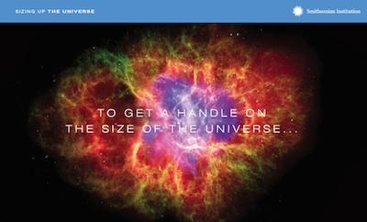 | Smithsonian Institution, Washington D. C., United States  http://learning.si.edu/idealabs/sizinguptheuniverse/#intro/  This interactive measures relative sizes and distances in space by comparing them to sizes and distances on Earth. This makes it easier to comprehend how large and ‘spacey’ the universe is.

Instructions:
- Click “Get started” and choose an object that could represent the size of the Earth:
  - Beach ball
  - Basketball
  - Brussels sprout
The above selection will be used as a baseline to show how other objects in the Solar System compare to everyday objects and how actual distances in space compare with distances in a local area through Steps 2 to 11.
- At Step 11, choose an object that could represent the size of the Solar System:
  - Quarter (U.S. 25 cent piece)
  - Cookie
  - Fried egg
The above selection will be used as a baseline to show to how the Milky Way compares to an area in the World.

Interactive 2 - The Scale of the universe
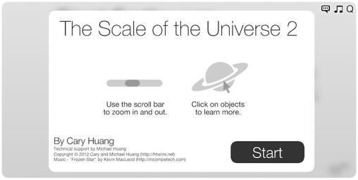 | Cary and Michael Huang, California, United States  http://htwins.net/scale2/  Inspired by Cosmic Voyage (a Smithsonian Institute film), this interactive showcases scale in our world, from the microscopic to the cosmic. It shows size, distance and other information for a huge range of objects.

Instructions:
- Click “Start” to see various objects and places used to demonstrate the relative sizes of the various SI multiples of a metre.
- Click and drag the scroll bar OR scroll with the mouse to zoom in and out.
- Click on an object to reveal a fun fact about the object and its actual size.

Suggested activity:
- Students explore the interactive and complete the following table:

Length (m) | An object with size close to this length | Actual length of the object (m) | Fun fact about the object (1 sentence)
1 × 10⁻⁹
1 × 10⁻⁶
1 × 10⁻³
1
1 × 10³
1 × 10⁶
1 × 10⁹
1 × 10¹²
1 × 10¹⁵
1 × 10¹⁸
1 × 10²¹
1 × 10²⁴

Interactive 3 - Stellarium
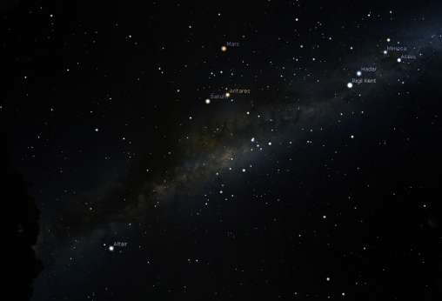 | Fabien Chéreau, Villefranche-sur-Saône, France  http://www.stellarium.org/  https://www.rollapp.com/app/stellarium  This free software allows exploration of the night sky in any location on the Earth, at any specific time and day. Users can zoom in and out to see the details of a selected object and access data related to this object.

Instructions:
- Download Stellarium or open the 2nd link and then click “Launch Online” then “Test Drive”.
- Move the mouse to the bottom-left corner to see toolbars that can be used to explore the sky
- Select location button to change the location where you are viewing the sky on Earth.
- Select atmosphere button to reduce the amount of sunlight.
- Select Date/time window button to set a specific date and time for the night sky.
- Click the Increase time speed button or Decrease time speed button to move quickly forward and backward in time.
- Click and drag the screen to look at different parts of the sky (arrow keys can also be used).
- To zoom into an object, click on the object, select Center on selected object button then scroll in.
- To see where star clusters, nebulae and galaxies are located on the night sky, select Deep-sky objects button . Different types of deep-sky objects are marked by different shapes:
  - = star cluster
  - = nebula
  - = galaxy

Suggested activity:
- Students explore the sky and complete the following table:

Type of celestial object | One sentence description | Example | Image of the example (screenshot from stellarium)
Artificial satellite
Moon
Dwarf planet
Planet
Star
Star cluster
Nebula
Galaxy

Interactive 4 - Galaxy Zoo
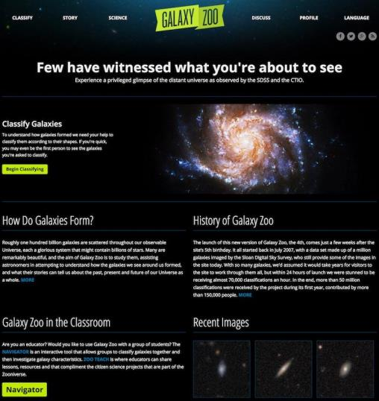 | Fabien Chéreau, Villefranche-sur-Saône, France  https://www.galaxyzoo.org/?_ga=1.161787516.1726421662.1464561173  This is a web-based citizen science project from Zooniverse that allows users to view real images of galaxies taken by astronomers and classify each galaxy based on its shape. It is free to signup for an account.

Instructions:
- Sign up for or login to a Zooniverse account (while it is not necessary to sign up, users with an account receive credit for the galaxies they have classified)
- Click Begin Classifying button to start classifying galaxies.
- If it is difficult to classify or understand what to look for, click the Examples button to see examples of images that are already classified.
- Sometimes inverted images make it easier to see certain details of the galaxy. To do this, click the Invert button.
- If a mistake is made, click the Restart button to classify the galaxy again.
- Teachers can use the Navigator button to classify galaxies together with the students as a class.

Extension:
- There are other space projects on the zooniverse webpage https://www.zooniverse.org/projects?discipline=astronomy&page=1

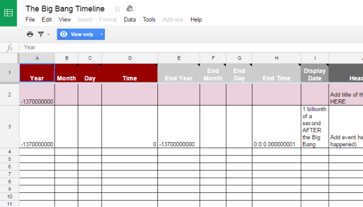
Practical Activities

Activity 1 - Big Bang Timeline
This activity integrates research and ICT skills to create a timeline of the Big Bang from the moment when the Universe came into existence to the formation of the Solar System and the present day.

Equipment:
- Computer with access to internet
- Google account

Method:
- Watch the following videos about the events after the Big Bang, taking notes on the important events and related timeframes/years/dates:
  - https://www.youtube.com/watch?v=hSZqhqR5XKM (History Channel - The Birth of the Universe: Big Bang and Beyond)
  - https://www.youtube.com/watch?v=l_Om5TNJVmE (King Crocoduck - A Brief Timeline of EVERYTHING)
- Open The Big Bang Timeline spreadsheet (https://goo.gl/8A5rAk) - this is the template for creating a timeline. Select “File” then “Make a copy…” to save an editable copy of the template to the Google drive.
- The first row under the headings is coloured PINK and this row is for the title of the timeline (see sample timeline for details).
- Edit the spreadsheet based on the events outlined in Step 1.
  - For the the first row, the “Year” column already has the year of the Big Bang entered: -13,700,000,000. This year is 13.7 billion years ago. Note that in the timeline, the year 0 is 1BC (or 2016 years ago if the current year is 2016), so any event that occurred in a year before 1BC will be in negative numbers.
  - The other rows, which are WHITE, are for each of the events to be include on the timeline. For example:
    - For something that happened 1 second after the Big Bang, enter -13700000000 for “Year” and 0:0:1 for “Time”.
    - For something that happened 9.2 billion years after the Big Bang, enter -4500000000 for “Year” (which is 4.5 billion years BC) and leave the “Time” field blank. The year is calculated by adding 9.2 billion years to -13.7 billion years.
  - Remember to fill in the “Display Date”, “Headline”, “Text”, and “Media” fields.
  - The links to following media can be displayed in the completed timeline:
    - YouTube
    - Vimeo
    - Soundcloud
    - Dailymotion
    - Instagram
    - Twitter picture
    - Twitter status
    - Google+ status
    - Wikipedia
    - Images (e.g. links that end with .jpg, .png, .gif, .svg)
- Go to https://timeline.knightlab.com/index.html#make and follow the instructions in the page. The bottom of the page, under the “Preview” will display what the published timeline will look like.
- Click the Get link to preview button to open a new window with the published timeline. Do one or more of the following:
  - Copy the link and email it to the teacher or yourself.
  - Copy the embed code and paste it into your personal webpage or blog.

Sample Timeline:
- To see a sample, go to https://timeline.knightlab.com/index.html#make and then enter the following link to a sample timeline (https://docs.google.com/spreadsheets/d/1Q5VjMPb4-eY_EED34EfFXoBjrL7OSasesfi5oeuhXPc/edit#gid=0)

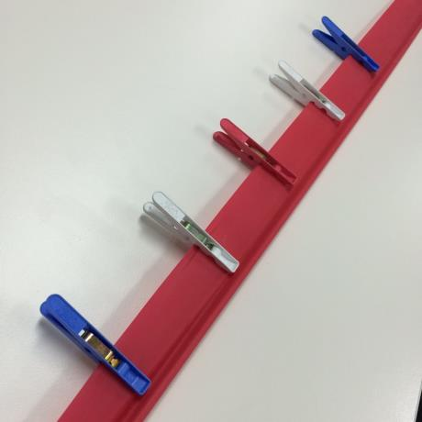
Activity 2 - Expansion of the Universe
This activity demonstrates how the Universe is continuously expanding, i.e. the space between the objects are growing instead of the objects drifting away from each other. It also demonstrates how farther away objects appear to move faster than the closer objects. Recommended to be done in groups of 3 or more.

Equipment:
- Elastic resistance band
- 5 clothes pegs
- Ruler

Method:
- Have two people hold opposite ends of the resistance band and move away from each other until the elastic is pulled straight but not stretched.
- Have another person clip the 5 pegs on the elastic, spacing the pegs 5 cm apart.
- The third person will now stand next to a peg. They will be the stationary observer.
- Have the people holding the ends of the resistance band move further apart until the distance between the observer’s peg and one of the adjacent pegs is 10 cm, as measured with the ruler.
- Measure the distances from observer’s peg to each of the other pegs.
- Repeat steps 1-5 with the stationary observer standing next to a different peg.

Discussion:
- Compare the distances measured. What did you notice?
- If the stretching of the band took 1 second, what can be implied about the speed of movement of each of the pegs from the observer’s peg?
- Was there any difference in the results when the observer was standing next to a different peg?

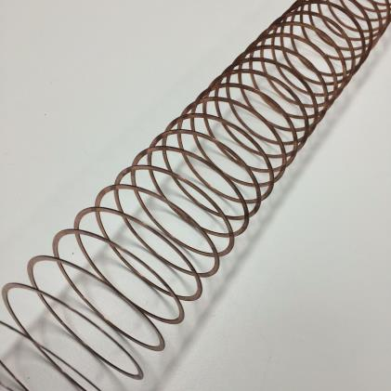
Activity 3 - Extremely simple redshift modelling
This is an extremely simple activity demonstrating how waves produced by a source will increase in wavelength (thus decreases in frequency) as the source moves away from an observer, and that waves decrease in wavelength if the source moves towards an observer.

Equipment:
- Metal slinky

Method:
- Two people hold opposite ends of the slinky and stand approximately 2 m apart.
- The people move away from each other slowly and notice what happens to the distance between the loops in the slinky, with each loop representing one wavelength. This is red shift.
- The two people return to the original position and then move towards each other slowly. Notice what is happening to the distance between the loops of the slinky. This is blueshift.

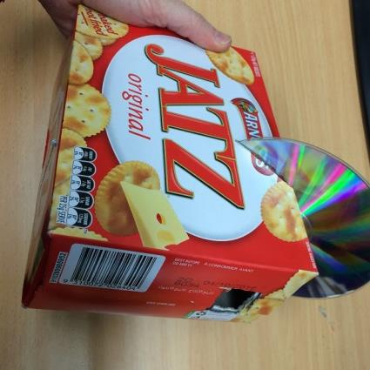
Activity 4 - Homemade spectroscope
This is an activity for students to create their own spectroscope to observe the diffraction of light and compare light spectra from a range of sources.

Equipment:
- Box (e.g. biscuit or cereal box)
- Marker pen
- Ruler
- Craft knife (may need teacher’s assistance)
- Old CD (or DVD) that is not longer needed

Method:
- Use the marker pen and ruler to mark where you will cut holes in the box as pictured below:
- CD slit, to hold the CD at an angle of 30°-45°
- Narrow slit, directly opposite the CD
- Viewing hole, directly above the CD, approximately 2 cm x 2 cm in size

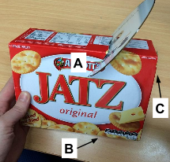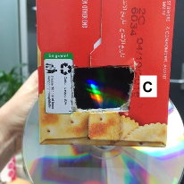

- Use the craft knife to carefully cut the holes and slits as marked.
- Slide the CD into the angled slit with the reflective side facing the viewing hole.
- Point the narrow slit towards a light source (e.g. fluorescent light) and change the position slightly until a clear spectrum appears on the CD when viewed through the viewing hole.

Note: A cleaner edge can be made for the narrow slit by cutting a wider hole and covering it with a narrow slit made using aluminium foil held in place with sticky tape.

Extension:
- Use the spectroscope to look at different sources of light e.g. Hydrogen lamp, Helium lamp and Neon lamp and compare the different spectra.

Adapted from: https://www.youtube.com/watch?v=ZowYVDQDDZ4

Useful Links
Below is a list of further links to supporting materials that may assist in teaching this topic.

- https://www.youtube.com/watch?v=9B7Ix2VQEGo
Crash Course - The Big Bang, Cosmology part 1: Crash Course Astronomy #42

- https://www.youtube.com/watch?v=IGCVTSQw7WU
Crash Course - A Brief History of the Universe: Crash Course Astronomy #44

- https://www.youtube.com/watch?v=eI9CvipHl_c
Deep Astronomy - A Journey into a Black Hole

- https://www.youtube.com/watch?v=vRjGarICal4
Smithsonian Institution - Cosmic Voyage (the powers of 10)

- https://www.youtube.com/watch?v=QAa2O_8wBUQ
Kurzgesagt - In a Nutshell: What is Dark Matter and Dark Energy?

- https://www.youtube.com/watch?v=4eKIjkk0NVY
ADVEXON TV - From The Big Bang To The Present Day

- https://www.youtube.com/watch?v=zLSe7RxtJ4o
MinutePhysics - AMAZING Simulation of the Evolution of the Universe

