Awesome Astronomy

These worksheets are designed to support a live CAASTRO in the Classroom session or a recording of a past session. The ‘Pre-visit activities’ can be completed prior to the video conference session and the ‘Post activities’ are provided as suggestions for follow-up activities.

Table of contents

Table of contents
Pre-visit Activities
Glossary
Post-visit Activities
Online Interactives
Interactive 1 - Solar System Scope
Interactive 2 - Design a planetary system
Interactive 3 - Finding exoplanets
Interactive 4 - Planet designer
Practical Activities
Activity 1 - Pocket Solar System
Activity 2 - Edible craters
Activity 3 - One Metre Sun (Solar System Model)
Activity 4 - Solar System Soft Drink
Activity 5 - Goldilocks Zone
Useful Links

Pre-visit Activities

Glossary
The following terms will be used during the video conferencing session or post-visit activities.
Activities to familiarise students with these terms may include: asking each student to learn about one term and share their knowledge with the class; making a matching game by printing out the table, cutting out each term and meaning, and matching the terms with their meanings; or asking students to work in pairs to share what they know about each word and to find out more about any unfamiliar words.

Terms | Definition
Asteroid | A small rocky object that orbits the Sun
Asteroid Belt | A region between Jupiter and Mars where there are asteroids in orbit around the Sun
Comet | A small object in the Solar System made up of a ball of ice and rock with a tail made of gas and dust
Dwarf planet | An object that orbits the Sun which is nearly round in shape, has other objects close to its orbital path, and is not a moon. Pluto is a dwarf planet.
‘Goldilocks Zone’ or ‘Habitable Zone’ | An area around a star where an orbiting planet could potentially support life
Gravity | A force of attraction between two objects due to their mass
Kuiper Belt | An area of the Solar System beyond Neptune that is believed to contain many comets and other icy objects, plus three officially recognised dwarf planets: Pluto, Haumea, and Makemake
Moon | A natural object that moves in an orbit around a planet
Orbit | The path of an object moving around another object due to gravity
Planet | An object that is massive enough to be round in shape and the largest object close to its orbit around a star. The 8 planets in the Solar System are: Mercury, Venus, Earth, Mars, Jupiter, Saturn, Uranus and Neptune.
Solar System | An arrangement of planets, dwarf planets, asteroids, comets and other objects that orbit the Sun due to gravity
Star | A huge ball of gas that emits light and other types of radiation
Sun | The star at the centre of the Solar System

Post-visit Activities

Online Interactives

Interactive 1 - Solar System Scope
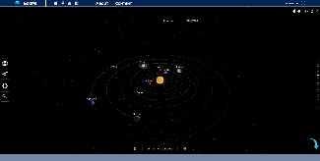 | Solar System Scope, INOVE, Europe  http://www.solarsystemscope.com/  This interactive provides a detailed view of the Solar System, in particular the Sun, planets, dwarf planets, moons and comets. It can be used to learn about the inside of each planet, and calculate how long it takes for a planet to orbit around the Sun.

Instructions:
- Click the interactive to start.
- The slider on the right controls zooming - move it up = zoom in, move it down = zoom out. Scrolling with the mouse also controls zooming - scroll up = zoom in, scroll down = zoom out.
- The “planet” button () on the left displays the Solar System viewed from outer space.
- The “telescope” button () on the left displays the Solar System viewed from Earth.
- The “settings” button () on the left provides options for viewing the Solar System.
- The “search” button () on the left is used to search for a specific planet, dwarf planet, comet, constellation, or major star.
- Click on the Sun or a planet in the solar system to access quick information about it.
- Double click on the Sun or a planet/dwarf planet/moon to zoom in and access more information about it:
  - Select “orbit” to view the object very closely
  - Select “planet system” (only available for the planets and moons) to view the planet system it belongs to
  - Select “structure” (available to certain objects) to view what it looks like inside (internal structure)
  - Select “show info” to access quick information or to view labels of an object’s internal structure
- The “play” button on the bottom shows how the Solar System moves over time. Move the slides to increase/decrease the time forwards/backwards.

Suggested activity:
- Measure the time taken for a planet to complete its orbit around the Sun:
  - Click and drag the space downwards until the complete Solar System looks like it is viewed from the top.
  - Click on a planet and drag it until it is positioned directly below the Sun (you may need to use the slider on the right so the orbit is completely visible within the window). Record the date in the table below.
  - Click on the planet and drag it around the Sun counter-clockwise, so that it completes one orbit. Record the date when the planet comes back the position directly below the sun.
  - Using the two dates, determine the number of Earth days required for the planet to complete one full orbit of the Sun (this is one year for the planet) and record your results for each planet in the table.

Time taken for the planet to orbit the Sun

Planet | Orbit start date | Orbit end date | Time for one complete orbit  (Earth days)
Mercury
Venus
Earth
Mars
Jupiter
Saturn
Uranus
Neptune

  - Compare the values calculated to the actual measurements and discuss reasons for any differences. Real data for “Orbital Period” can be found on this NASA website: http://nssdc.gsfc.nasa.gov/planetary/factsheet/.

Interactive 2 - Design a planetary system
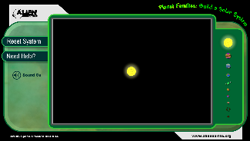 | Space Science Institute, Boulder, USA  http://www.alienearths.org/online/interactives/planet_families/main.html  This interactive allows the user to create their own planetary system and to see how each celestial object in the system affects the movement of other objects due to gravity.

Instructions:
- Choose a celestial object on the right then drag and drop the object into a position on the screen.
- Observe how the object moves around the star.
- Add more objects and observe how they interact with each other.
- Click “Reset System” to start again.

Suggested activities:
- Observe the following interactions for about 2-3 minutes each and note any interesting changes or noticeable differences:
  - A small planet near the star
  - A large planet near the star
  - Two small planets near the star
  - Two large planets near the star
  - A small planet near the star and a large planet at a slightly larger distance from the star
  - A large planet near the star and a small planet at a slightly larger distance from the star
  - A small planet, a medium planet and a large planet placed consecutively from the star
  - A large planet, a medium planet and a small planet placed consecutively from the star
  - A large planet, a small planet and a large planet placed consecutively from the star
  - Another star
- Create a stable system with as many planets as possible. To be stable, each planet in the system should stay in orbit around the star for at least 5 minutes, with the shape of each orbit staying the same.
  - Compare the completed planetary system with those created by other students in the class
  - Take a screenshot of the completed planetary system

Interactive 3 - Finding exoplanets
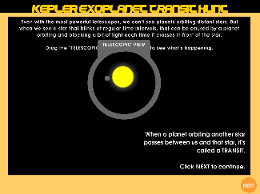 | NOTE: This is a challenging activity!  NASA Ames Research Centre, Moffett Field, USA  http://kepler.nasa.gov/multimedia/Interactives/keplerFlashAdvDiscovery/flash.cfm  This interactive provides information about 12 exoplanets which can be used to make measurements and calculations to determine whether each exoplanet is habitable or not. It provides users with a taste for what astronomers do and provides an opportunity to use numeracy skills.

Instructions:
- Drag the TELESCOPIC VIEW over the star (small white dot) to see it close up and to activate the NEXT button. Click the NEXT button to start the activity.
- There are 12 stars, each with an exoplanet. Click on a star to access information about the star. Drag and drop the Star’s Type (spectral type), Star’s Mass (in Sun Masses), Star’s Radius (in Sun Radii) and Star’s Temperature (°K) into relevant boxes located in the ‘NOTEBAR’ at the bottom of the screen. The data are colour coded to make it easier to drag and drop.
- Click the NEXT button and follow the instructions on the left to collect data on the days between ‘blinks’ and how much the brightness of the star drops for each blink. Each blink is when the exoplanet moves in front of the star, or ‘transits’, blocking out some of the star’s light. After collecting the data, follow the instructions on the right to drag the scale and use it like a ruler on the graph to measure and record values for Exoplanet Orbital Period and % Brightness Drop. Enter the values in the relevant boxes in the ‘NOTEBAR’.
- Click the NEXT button. To calculate the distance of the exoplanet from the star, drag and drop the Exoplanet Orbital Period from the ‘NOTEBAR’ into the period (earth days) box located in the instructions. Click the CONVERT button. Drag and drop Star’s mass from the ‘NOTEBAR’ into the Star’s mass box located in the instructions then click the Calculate button. This will produce a value for Distance (AU). Drag and drop the value for Distance (AU) to the DISTANCE box in the ‘NOTEBAR’.
- Click the NEXT button. Follow the instructions to determine the location and the size of the habitable zone and whether the exoplanet is within the zone. You will need to use the Star’s Temperature and Distance (AU). Write Y for ‘yes’ or N for ‘no’ in the In Habitable Zone? box in the ‘NOTEBAR’.
- Click the NEXT button. To determine the exoplanet’s temperature, drag and drop Star’s Temperature (°K), Star’s Radius (in Sun Radii) and Distance (AU) into the relevant boxes located in the instructions and click the CALCULATE button. Drag and drop the Exoplanet Surface Temp (°K) into the relevant box in the ‘NOTEBAR’.
- Click the NEXT button. To determine the size of the exoplanet, drag and drop Star’s Radius (in Sun Radii) and % Brightness Drop into the relevant boxes located in the instructions and click the CALCULATE button. Drag and drop the Exoplanet Radius (in Earth Radii) into the relevant box in the ‘NOTEBAR’.
- Click the NEXT button. A summary page comparing the Earth and the exoplanet will appear. Take a screenshot of the summary and save the image as a .png or .jpg file.

Interactive 4 - Planet designer
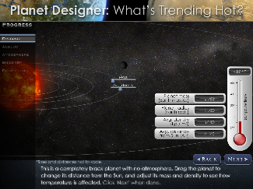 | University of Colorado, Boulder, USA  Part 1: Martian Makeover  http://lasp.colorado.edu/home/education/k-12/project-spectra/martian-makeover-interactive/  Part 2: What’s trending hot?  http://lasp.colorado.edu/home/education/k-12/project-spectra/trending-hot-interactive/  The first interactive explores how the planet Mars has changed over time, from a planet that was much more similar to the Earth, to the dry and desolate red planet we see today. The second interactive allows the user to design and new planet.

Part 1: Martian Makeover instructions:
- Briefing
  - Click the NEXT button to watch the animations and information about Mars today and in the past and learn about how and why its atmosphere changed over time.
  - Suggested questions:
    - What colour does Mars appear to be?
    - What are the ice caps at the poles of Mars made out of?
    - How do we know there were once lakes, rivers and possibly oceans on Mars a long time ago?
    - How far away is Mars from the Sun?
    - What did Mars look like 3.8 billion years ago?
    - Why is a thick atmosphere with greenhouse gases necessary for liquid water?
    - Why was the atmosphere of Mars blown away by the Solar Wind while Earth’s atmosphere was not?
    - What happened to the water on Mars once there was not enough atmosphere?

- MAVEN Mission - Mars Atmosphere and Volatile Evolution Mission
  - The first page of this section has THREE buttons, each linked to a video:
    - Questions for MAVEN mission
    - The How-To Guide to Satellites, Part 1
    - The How-To Guide to Satellites, Part 2

- Mars Stats & Snapshot
  - Suggested questions
    - How big is Mars compared to Earth?
    - What is the distance of Mars to the Sun compared to Earth? The distance of the Earth to the Sun is 1 AU = 1 astronomical unit.
    - What is the temperature on Mars?
    - How could humans survive on Mars? What would they need?

- Makeover
  - Adjust the sliders to increase or decrease the Atmosphere thickness and Greenhouse strength in Mars.
  - The barometer and thermometer on the screen show the average atmospheric pressure and temperature of Mars as the atmosphere changes.
  - Suggested questions:
    - What would Mars look like if it had the same amount of atmosphere and greenhouse effect as Earth?
    - Describe the atmosphere and the greenhouse effect on Mars when it had flowing liquid water in lakes and streams.

Part 2: What’s Trending Hot? instructions:
- The aim is to create a planet with liquid water, since water is essential for life.
- Drag the planet left or right to choose its Avg. distance from the Sun.
- Adjust the slider for Mass and for Avg. density to increase or decrease the size of the planet and how densely packed its matter is.
- The thermometer will display the average temperature of the planet according to the planet’s mass, density and average distance from the Sun.
- Click NEXT to colour the planet to increase or decrease its Albedo. This will determine the amount of sunlight reflected off the planet’s surface. The higher the albedo, the colder the planet becomes.
- Click NEXT to adjust the sliders for Atmosphere thickness and Greenhouse strength until the planet has liquid water (similar to Part 1).
- Click NEXT to access the summary of the planet - write the information down on a notebook OR take a screenshot and save the image.
- Suggested activities:
  - Set the Mass and Avg. density of the planet to be the same as the Earth.
    - What is the FARTHEST distance the planet can be and still have liquid water?
    - If it was at the same distance as Mercury, what is the minimum amount of albedo required for the planet to have liquid water?

Practical Activities

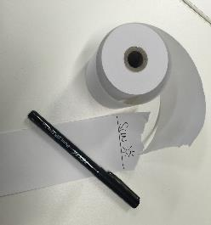
Activity 1 - Pocket Solar System
This activity uses a piece of long paper and a marker to demonstrate the distances between the planets in the Solar System. At the end, students can keep this Solar System model in their pocket/wallet/bag. This can be done as a guided activity, with the teacher reading out the instructions and asking students to suggest which planet name should be written at each position.

Equipment:
- Paper register roll
- Pen

Method:
- Ask students to recall the names of the planets and their order from the Sun.
- Measure out and tear off an arm span length of register paper.
- At the very end of the paper, write the word “SUN” and at the other end, write “PLUTO” (note that Pluto is classified as a dwarf planet).
- Fold the paper in half (so that SUN and PLUTO touch each other) and make a crease in the middle of the paper. Unfold the paper and write “URANUS” on the crease.
- Fold the paper back in half, and then fold it in half again. Unfold the paper completely - there should be two new creases, one between the SUN and URANUS and one between URANUS and PLUTO.
- Write “NEPTUNE” on the crease between URANUS and PLUTO.
- Write “SATURN” on the crease between the SUN and URANUS.
- Fold the SUN end of the paper to SATURN, unfold and write “JUPITER” on the crease.
- Fold the SUN end of the paper to JUPITER, unfold and write “ASTEROID BELT” on the crease.
- Fold the SUN to the ASTEROID BELT, unfold and write “MARS”
- Fold the SUN to MARS and then fold the doubled section in half again. When you unfold the paper you should see three new creases between the SUN and MARS at the positions where the innermost planets are located. Write “MERCURY” on the crease closest to SUN, then “VENUS”, and then “EARTH”.

Extension:
- Decorate the Solar System model with pictures and colours.
- Calculate and compare the relative distances of the planets from the Sun in this model with the actual distances.
- Devise a model for the relative sizes of the planets using everyday items (hint: use a Fitness ball or large beach ball for the Sun).

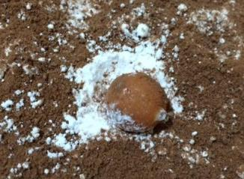
Activity 2 - Edible craters
Make a delicious recreation of crater formation on the tasty surface of a fictitious planet! Craters are formed when an asteroid strikes a rocky planet, moon or dwarf planet. Mercury has the most craters of the rocky planets in our Solar System because it has no atmosphere to erode away the craters.

Equipment:
- Large tray
- Icing sugar or flour (enough to cover the tray to 1-2 cm deep)
- Tin of powdered chocolate drink (e.g. Milo, Nesquick or Ovaltine)
- Hard sweets of various sizes
- Paper fans (or paper to make fans)

Method:
Note: This is a messy activity and is best done outside, in a sheltered area away from any wind.
- Spread the icing sugar or flour over the tray and sprinkle a thin layer of powdered chocolate over the icing sugar until there is little or no white visible. This is the surface of the planet.
- The hard sweets represent asteroids striking the surface of the planet. Ask students to take it in turns to drop the ‘asteroids’ on the surface of the planet. For each asteroid, record:
  - The size of the asteroid
  - The height from which it is dropped
  - The diameter of the crater formed on the surface of the planet
- Use paper fans to create wind across the surface of the planet and observe what happens to the craters. This models the effect of atmospheric winds eroding craters on the surface of a planet.
- Eat the sweets!

Suggested activities:
- Look at images of the Moon and Mercury and compare the size and shapes of the craters to the edible craters in this activity.
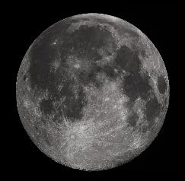 | 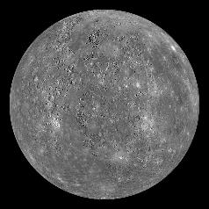
The Moon  Image by Gregory H. Revera, CC BY-SA 3.0, https://commons.wikimedia.org/w/index.php?curid=11901243 | Mercury  Image by NASA/Johns Hopkins University Applied Physics

Activity 3 - One Metre Sun (Solar System Model)
If the Sun was 1 metre wide, how big would the other objects in the Solar System be? Ask students to estimate the relative sizes of objects in the Solar System before making a scale model using real data.
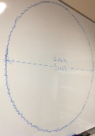
Equipment:
- 1 metre wide Sun - For example, draw a circle of 1 metre diameter on a whiteboard, find a 1 metre round ball such as a gym ball or beach ball, or decorate a 1 metre diameter circle of cardboard to look like the Sun.
- Paper and pencils
- Ruler
- Plasticine
- Bamboo skewers
- Trundle wheel or long tape measure (10 or 20 metres)

Solar System data
Object | Real diameter (km) | Scaled diameter (mm) | Real orbit radius (km) | Scaled orbit radius (m)
Sun | 1 391 900 | 1000 | - | -
Mercury | 4 866 | 3.4 | 57 950 000 | 42
Venus | 12 106 | 8.6 | 108 110 000 | 78
Earth | 12 742 | 9.1 | 149 570 000 | 107
Mars | 6 760 | 4.8 | 227 840 000 | 164
Jupiter | 142 984 | 102.7 | 778 140 000 | 559
Saturn | 116 438 | 83.6 | 1 427 000 000 | 1 025
Uranus | 46 940 | 33.7 | 2 870 300 000 | 2 062
Neptune | 45 432 | 32.6 | 4 499 900 000 | 3 233
Pluto | 2 274 | 1.6 | 5 913 000 000 | 4 248
Data from online calculator at http://www.exploratorium.edu/ronh/solar_system/
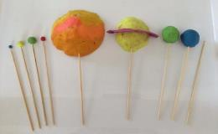
Method:
- Look at the 1 metre wide Sun and discuss the fact that the real diameter of the Sun is 1,391,900 kilometres.
- Use the paper and pencils to draw the planets (and dwarf planet Pluto), estimating how big they should be compared to the 1 metre wide Sun.
- Use the ruler and the real data in the table to make scale models of the planets (and dwarf planet Pluto) out of plasticine. The objects will be easier to carry if placed on the pointy end of a bamboo skewer.
- This step is best done in a large open space outdoors, such as an oval. Use the trundle wheel or tape measure to mark out the distance from the Sun to each of the three innermost planets: Mercury, Venus and Earth.
- Discuss the distances to the other objects.

Suggested activities:
Use a scale map of the school’s local area or an app such as Google Maps to find local landmarks that are at the locations of each of the more distant objects in the Solar System. For example, Jupiter might be at the nearest cross street and Saturn at the Railway Station.

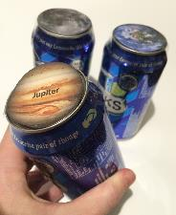
Activity 4 - Solar System Soft Drink
How much does a soft drink can weigh on the various objects in the Solar System? Students can be challenged with finding materials to add to empty soft drink cans to make them weigh the right amount.

Equipment:
- 1 full soft drink can
- Kitchen scales
- 9 empty soft drink cans
- Materials for adding weight to the empty cans, for example, 5 cent coins, water, sand, gravel

Method:
- Use the kitchen scales to measure the weight of the full soft drink can. For a can of lemonade, the weight will be about 420 grams. Label the full can “Earth”.
- Use the table to find the weight for other objects in the Solar System and add weight to each of the empty cans until it matches the weight for one of the objects in the Solar System. Label the can with the Solar System object it matches (see labels on the following page).

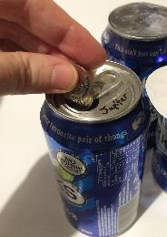
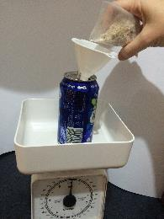
Weight of can of soft drink on objects in the Solar system
Solar System Object | Weight of a can of soft drink  (grams)
Mercury | 159
Venus | 381
Earth | 420
Moon | 69
Mars | 158
Jupiter | 993
Saturn | 447
Uranus | 373
Neptune | 473
Pluto (dwarf planet) | 28
Sun | 11 370

Hints:
- For Jupiter, we used 160 x 5 cent coins to achieve a total weight of 993 grams.
- A full can of water will weigh about 330 grams.
- A soft drink can on the Sun is too heavy to model using everyday materials. You would need over 4 000 x 5 cent coins to make up the weight of 11 370 grams (11 kilograms)!

Explanation:
It may be surprising to discover that the weight of a can of soft drink on Saturn is very close to the weight of the same can on Earth. The weight force on the surface of a planet, dwarf planet (Pluto) or the Moon depends on two things: the mass of the object and the size (radius) of the object. So, even though Saturn has a lot of mass, the mass it spread out to a large size so the weight force on Saturn’s surface is relatively small.

Suggested activity:
Label the cans on the bottom instead of the top to create a guessing game. Students pick up each can and try to guess the object in the Solar System that matches the weight and then use kitchen scales to measure the weight.

Labels for Solar System Soft Drink cans:
Image sources: NASA, ESA, The Hubble Heritage Team (STScI/AURA), JPL and Johns Hopkins University Applied Physics
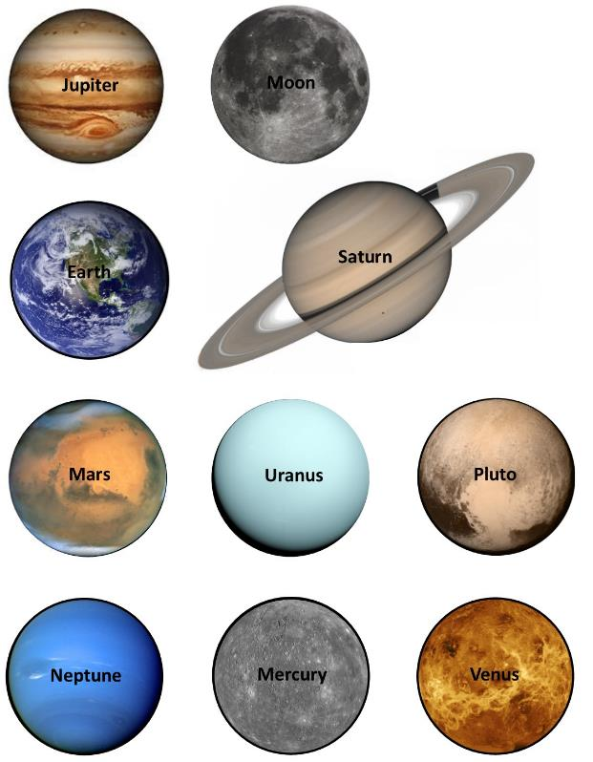

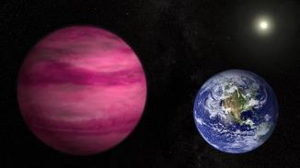
Activity 5 - Goldilocks Zone
Explore the concept of the ‘Goldilocks Zone’ through storytelling and drama.

Introduction:
The ‘Goldilocks Zone’, also known as the ‘Habitable Zone’, is an area around a star where an orbiting planet could potentially support life. The Earth is in the Goldilocks Zone of our Sun which means the Earth is not too hot and not too cold - it is just right!

Water is essential for life as we know it. If the Earth were close to the Sun, like Mercury, it would be too hot for liquid water to exist on the surface of the planet. If the Earth were further from the Sun, all of the water on Earth would freeze.

Another important feature of the Earth is the atmosphere - this traps heat via the greenhouse effect and keeps the planet’s surface within a fairly narrow range of temperatures. Compare this to Mars which has a very thin atmosphere which cannot trap enough heat to support life so the average temperature on Mars is about minus 60℃.

An exoplanet is a planet that orbits a star outside our Solar System. Using NASA’s Kepler Space Telescope, astronomers have discovered over 3 000 exoplanets, including some that seem to be in the ‘Goldilocks Zone’.

Activity:
Students are asked to imagine three fictitious planets that are orbiting a star and create a story, play or visual artwork to show how life might exist on each planet. Students can invent names for the star and the three planets and include characters such as humans, aliens or animals in their creations. The story should include some key features of each planet such as what is looks like, the temperature of the planet and whether or not there is liquid water on the planet. Here is an example set of three planets that can be used for the activity, or students could be challenged to invent their own:

Planet 1 - Orbits close to the star. No atmosphere. Very hot and dry.
Planet 2 - Orbits the star within in the ‘Goldilocks Zone’. This planet is much like the Earth.
Planet 3 - Orbits a long way from the star and the surface is very cold.

Examples of storylines:
- A space traveller journeys to each of the three planets, describing what they see and who they meet.
- A commercial for space tourism, showcasing the features of each travel destination, including suggestions for what clothes to pack.
- An alien searching for a new home.

Some sources of information for researching the ‘Goldilocks Zone’:
NASA Science News: http://science.nasa.gov/science-news/science-at-nasa/2003/02oct_goldilocks/
HowStuffWorks: http://science.howstuffworks.com/other-earth1.htm
ABC Science News: http://www.abc.net.au/news/2016-02-22/goldilocks-zones-habitable-zone-astrobiology-exoplanets/6907836
Space Scoop: http://www.unawe.org/kids/unawe1347/

Useful Links
Below is a list of further links to supporting materials that may assist in teaching this topic.

- http://www.atnf.csiro.au/outreach/education/teachers/viewing/index.html
Tips for holding a telescope viewing night at your school, from CSIRO

- http://www.unawe.org/
Universe Awareness - Offering a huge range of resources for children aged 4 to 10 years

- http://www.spacescoop.org/
Astronomy and space science news written for an 8 year old reading level.

- http://solarsystem.nasa.gov/planets/
NASA Solar System Exploration

- http://www.abc.net.au/science/starhunt/
ABC Science ‘Beginner’s Guide to the Night Sky’

- http://www.bbc.co.uk/schools/gcsebitesize/science/edexcel_pre_2011/space/planetsstarsandgalaxiesrev1.shtml
BBC Bitesize Science, ‘Planets, stars and galaxies’

- http://gravitycentre.com.au/
Gravity Discovery Centre in Western Australia, offering online resources and school visits

- https://www.vssec.vic.edu.au/
Victorian Space Science Education Centre, offering an immersive experience for school students and educational resources

- https://maas.museum/event/space/
Powerhouse Museum ‘Space’ exhibition, located in Sydney

- http://codementum.org/exoplanets/
Interactive version of XKCDs exoplanets

- https://exoplanets.jpl.nasa.gov/interactable/11/index.html
‘5 Ways to Find a Planet’, with a clear explanation of methods used to find exoplanets

- http://www.nytimes.com/interactive/science/space/keplers-tally-of-planets.html?_r=0
Kepler’s Tally of Planets, an animated graphic showing exoplanets discovered by NASA’s Kepler mission

