Researcher Profile: Luz Angela Garcia
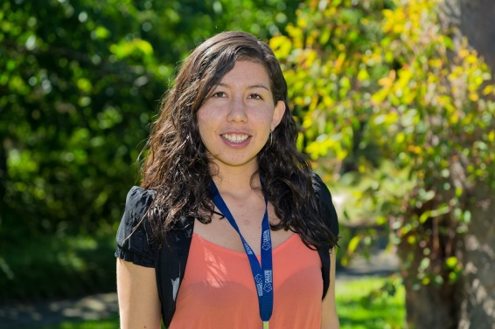

Fast Facts

Name
Luz Angela Garcia

Job title
PhD Student, Swinburne University of Technology

Where did you go to primary school and secondary school?
I went to primary and secondary school in Centro de Educativo Integral (Integral Educational Centre) in Bogotá, Colombia.

When you were a child, what did you want to be when you grew up?
When I was a kid, I wanted to be an astronaut, as many at my age. Then, I realised that I was skilful in maths and I felt really interested to science, especially biology and physics.

Where have you studied since finishing school?
I did my Bachelor of Physics and Master in Astronomy at Universidad Nacional de Colombia (National University of Colombia). In 2014, I moved to Melbourne to start a PhD in Astronomy at Swinburne University of Technology.

Where have you worked?
I worked as a tutor during my Masters degree, teaching special relativity and general relativity. In 2013 and 2014, I was teaching physics for engineers, including thermodynamics, mechanics, waves and oscillations. Since 2014, I have run some Astrotours in the 3D theatre at Swinburne University of Technology.

Describe your research in 150 characters or less.
The Big Bang Theory is the most widely accepted explanation of how the universe was formed 13.8 billion years ago: a single point of energy that rapidly expanded and evolved to create the universe. A few hundred million years after the Big Bang there was a period in the evolution of the universe called the “Epoch of Reionisation” (EoR). This was when the first stars began to shine and neutral hydrogen atoms became ionised (electrically charged) by high energy radiation from stars and galaxies. I look at data from about one billion years after the Big Bang to determine the ratios of neutral to ionised hydrogen and discover more about this period in the universe’s history.

What is the best part of your job?
I guess that we try to simulate events in the evolution of the universe, even when we can't actually see these events with the current technology. Using simulations allows us to combine different techniques to understand the early universe with a very high precision.

Name one impressive instrument that you’ve used for your research.
Supercomputers

What skills are essential to your job?
Physics, computer programming, collaboration and lots of imagination!

What advice would you give a school student who wants to become a scientist?
To be curious and always aware of the phenomena of nature. Also, it is important to learn programming and to be open to learning new things every day.

What are some futuristic applications that might come from your research?
We can look further and further into the early universe.

What do you do for fun in your spare time?
Painting, exercising, learning how to play the bongos and reading.

Twitter handle
@langelagp

Research in detail

My work is focused on the Epoch of Reionization (EoR), which was the period in the history of the universe when the first stars began to shine. During this time, hydrogen in the intergalactic medium (IGM) became ionised (electrically charged) due to high energy photons coming from powerful and energetic sources in the early universe. These sources of high energy photons were the first stars, galaxies, quasars and black holes.

The most common way of studying the EoR is by looking at the light and other radiation emitted by quasars. Quasars are extremely distant, bright objects in the universe, and we can study the light spectra from quasars and look for the amount of light that is absorbed by hydrogen and other elements in the universe. My research is working on a new approach to the problem. We model the physical properties of the intergalactic medium using computer simulations and then look at the spectra of quasars. We look for how light is absorbed by metals (instead of hydrogen) and this absorption appears as ‘absorptions lines’, which are black lines, in the spectra. Metals are not as abundant as hydrogen in the IGM, but they can tell us a lot about the EoR. There are also some real observations from radio telescopes that we can compare with our simulated results.

Images

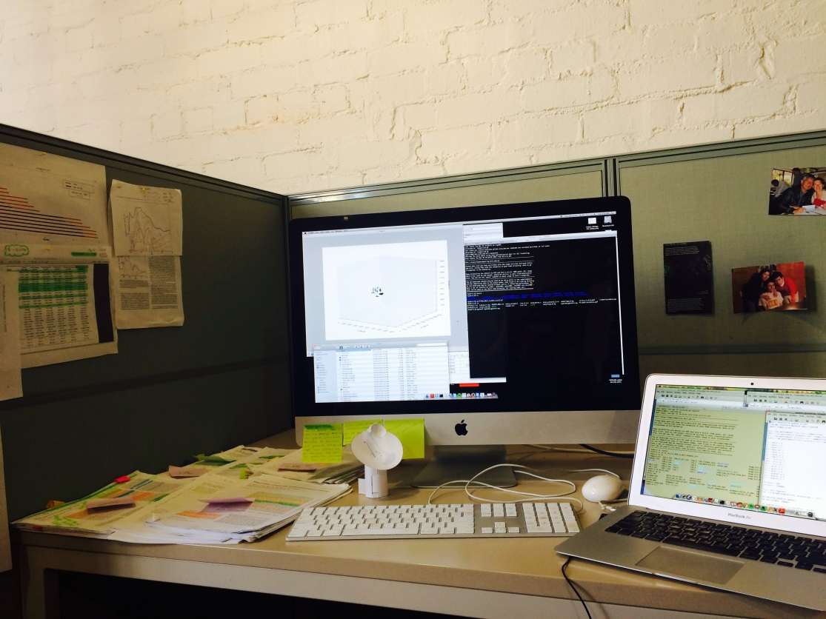
Workstation with computer running simulations

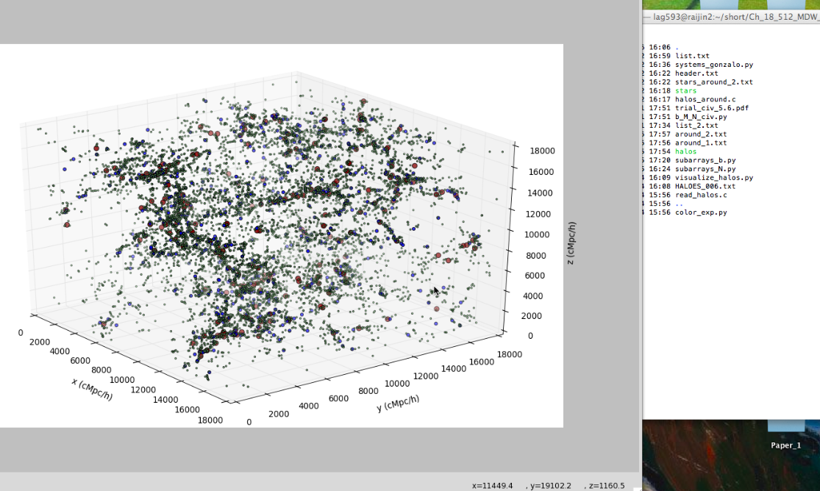
Screenshot of computer simulation

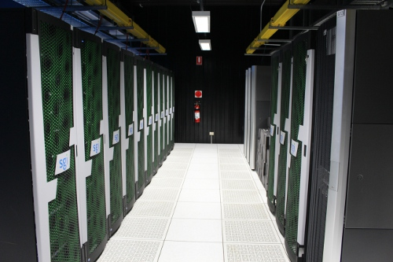
Supercomputer at Swinburne University of Technology

